# Title page

Diamond Salon

**User Manual**

**Web-Development**

**Version: 1.0**

**Date: 12/10/2020**

**Inspire the world and create more possibilities.**

**By Pragati Gupta**

‘

# Abstract

This Website allow to organize the product and services provided by Diamond saloon. It allows user to do the booking online and also to purchase products from the website. This website is dream for people who love fashion and makeup.

Contents

Title page 1

Abstract 2

Sign up 4

Login 5

Home Page 6

Make-up 9

Booking Service 11

Procut services 12

Hair care 14

Nail Care 15

About Us page: 16

Database 17

# Sign up

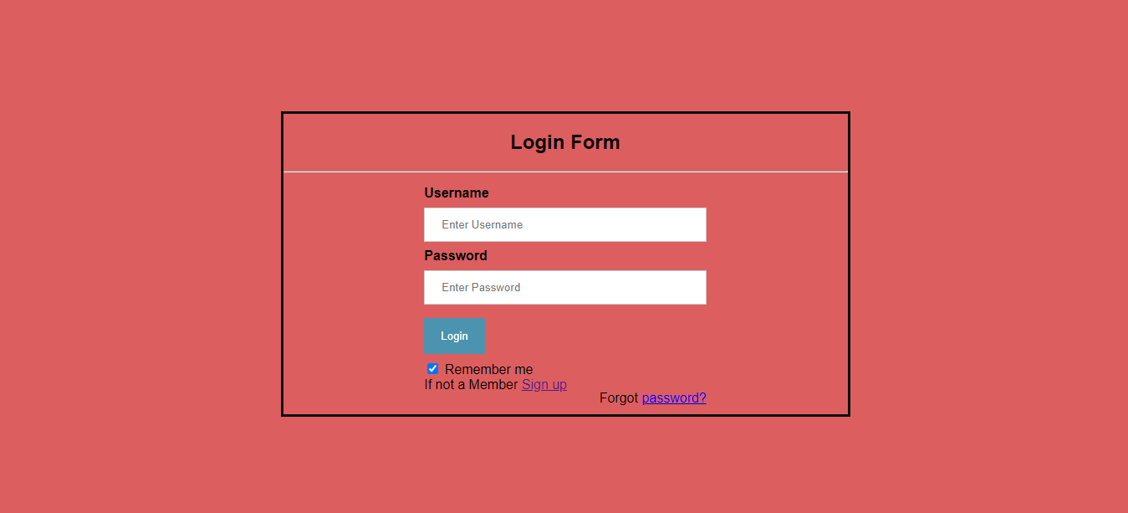To sign up to the application user need to click the **Sign up now** link on the Login page.

User can enter their email ID, Password and name at the sign-up portal and hit the submit button.

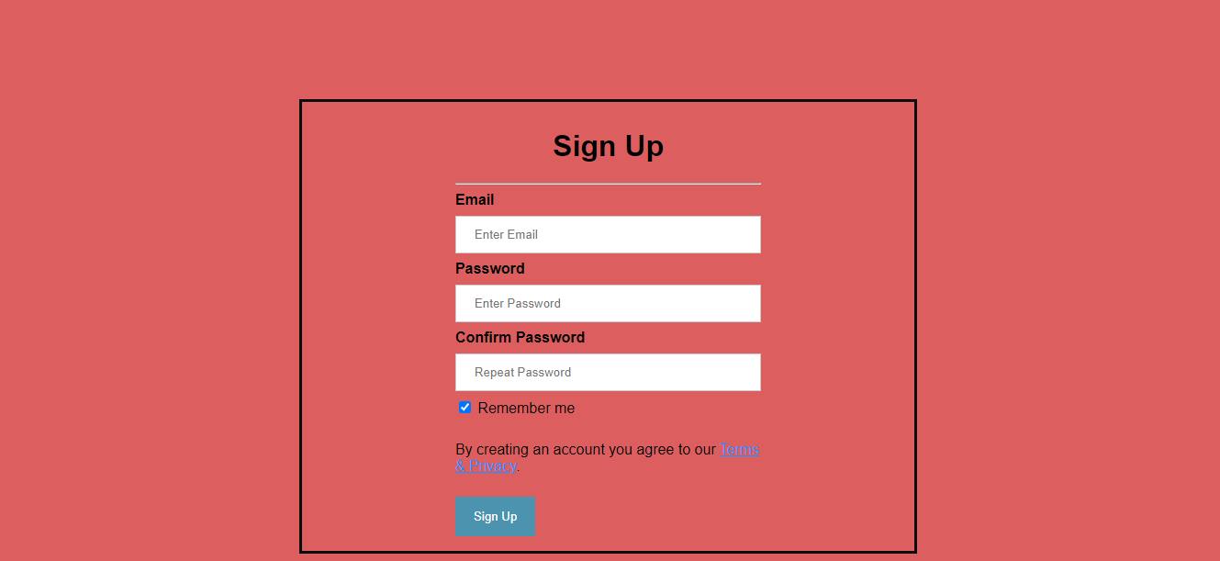

Once you hit the submit button, if the registration is successful then user will be redirected to Login Page

# Login

Login page that will only allow registered user (instructors) to login to create an online learning environment for their course.

To login to the application user need to provide the email id and password which is provided at the time of registration.



# Home Page

Home page provides the dashboard where user quickly sneek everything about the saloon. Home page have three sections :

* About US
* Services
* Products
* Gallery
* Contact US

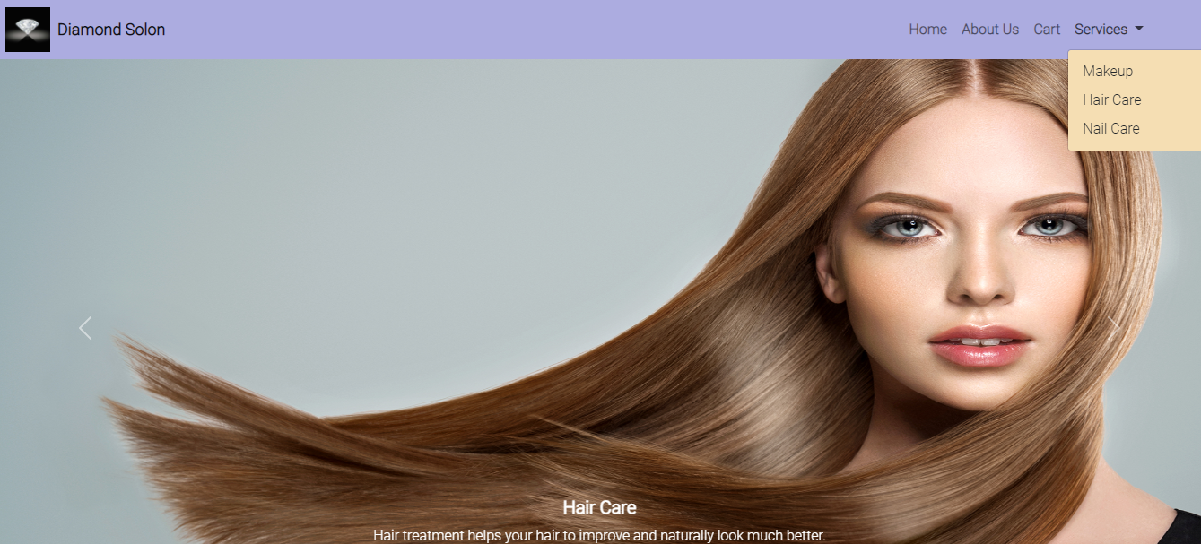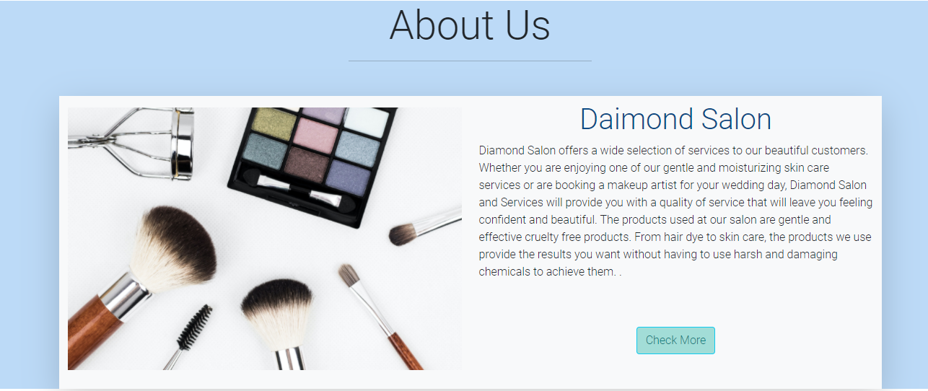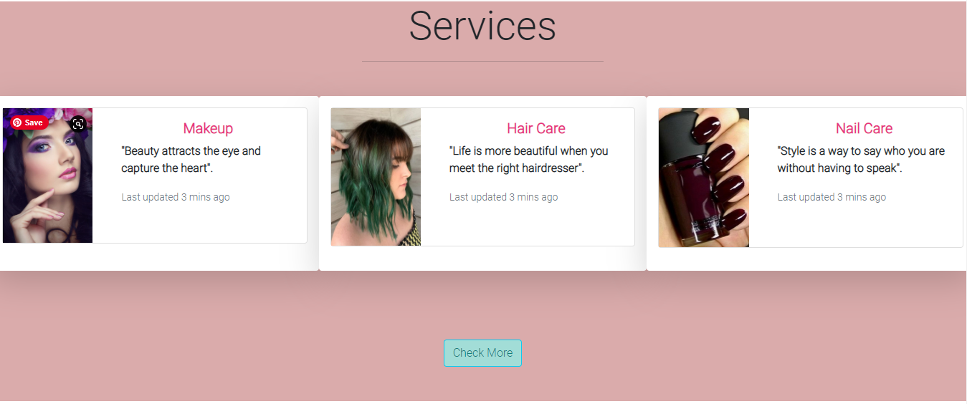

User can submit the nessaccary details to submit any query to the salon. Once user submit the page. The will get auto generate confirmation page.

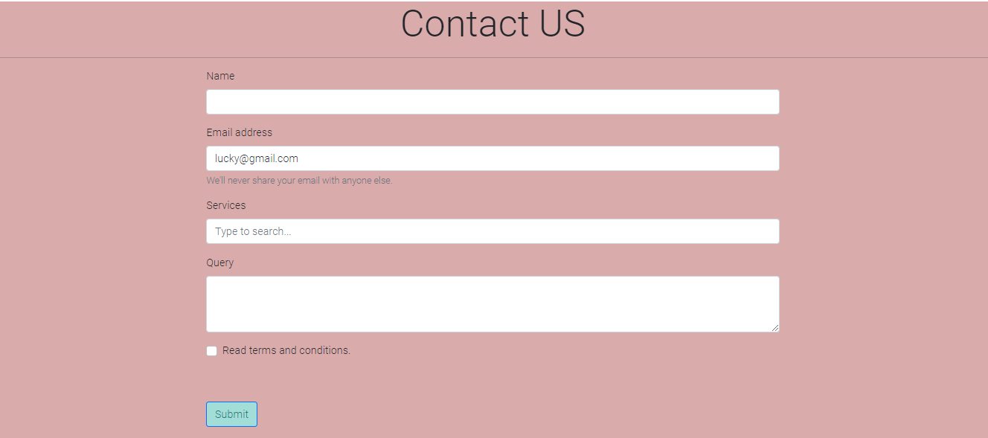

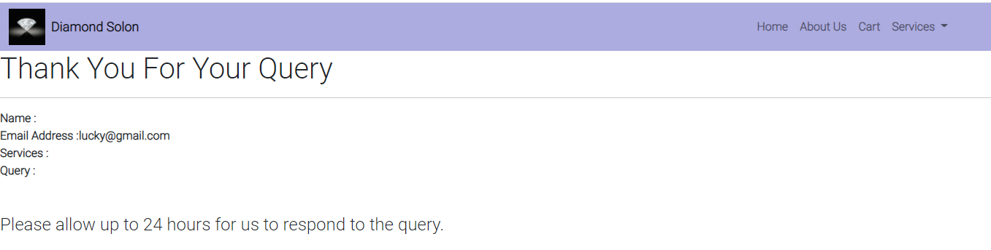

# Make-up

User can select the services section from the top right corner of home page and click on the makeup to navigate to make up page.

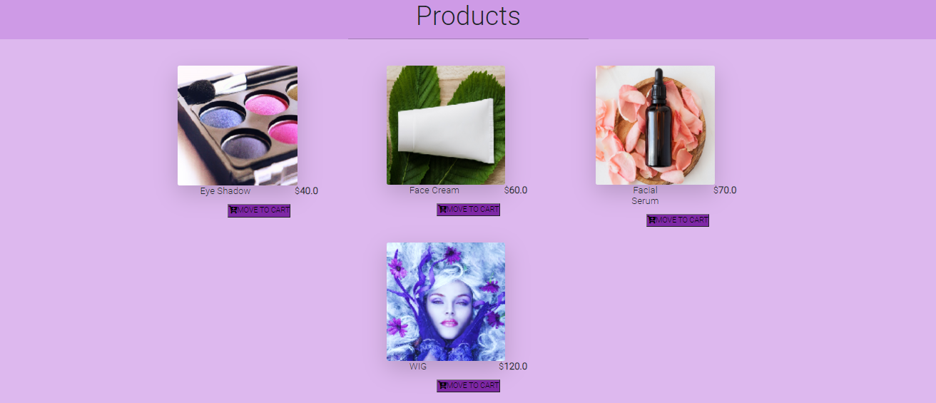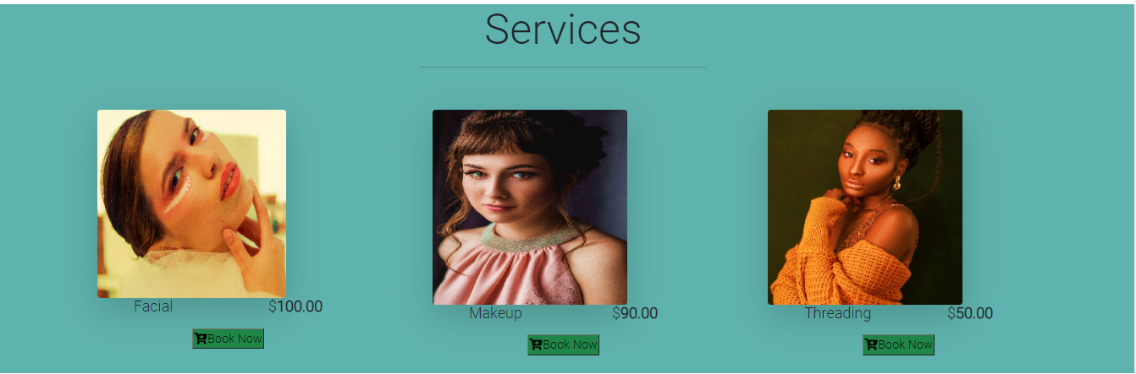

Make page provides two services:

* Booking Face Care Service
* Shopping Product

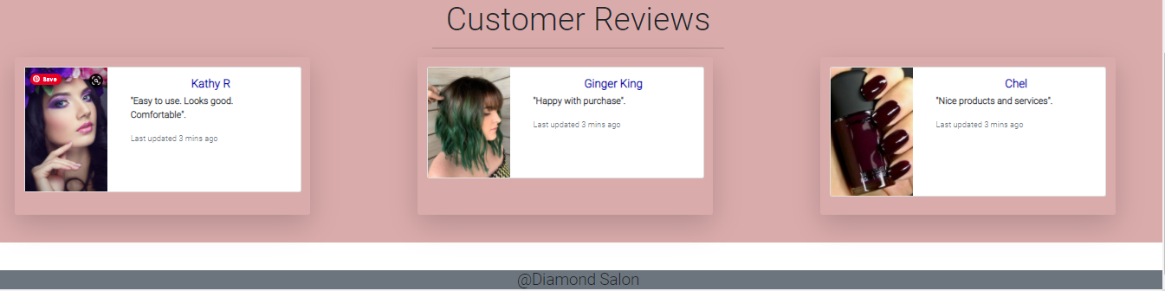

# Booking Service

To book any services, user need to click on book now button.

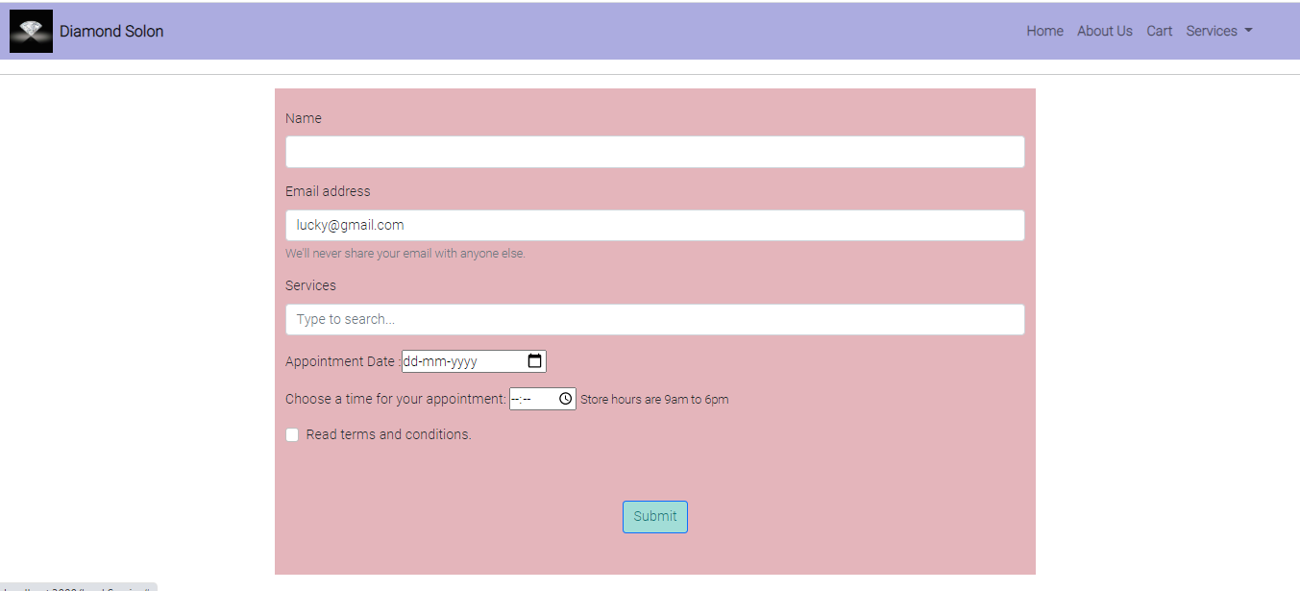

User need to provide details such as name, service type, appointment date and time and then submit the book now button.

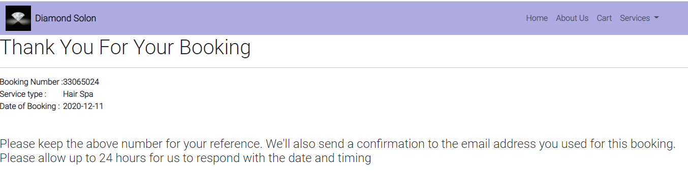Then user will get the below confirmation page, after the successful booking

# Procut services

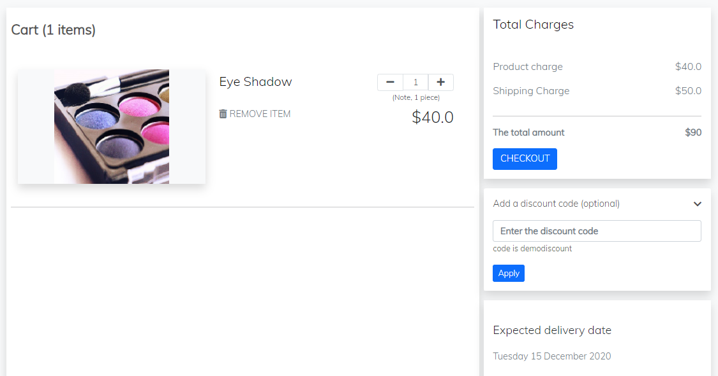User can click on add to cart button to add any product into the cart. User can select the cart option from navigation bar to go to the cart.

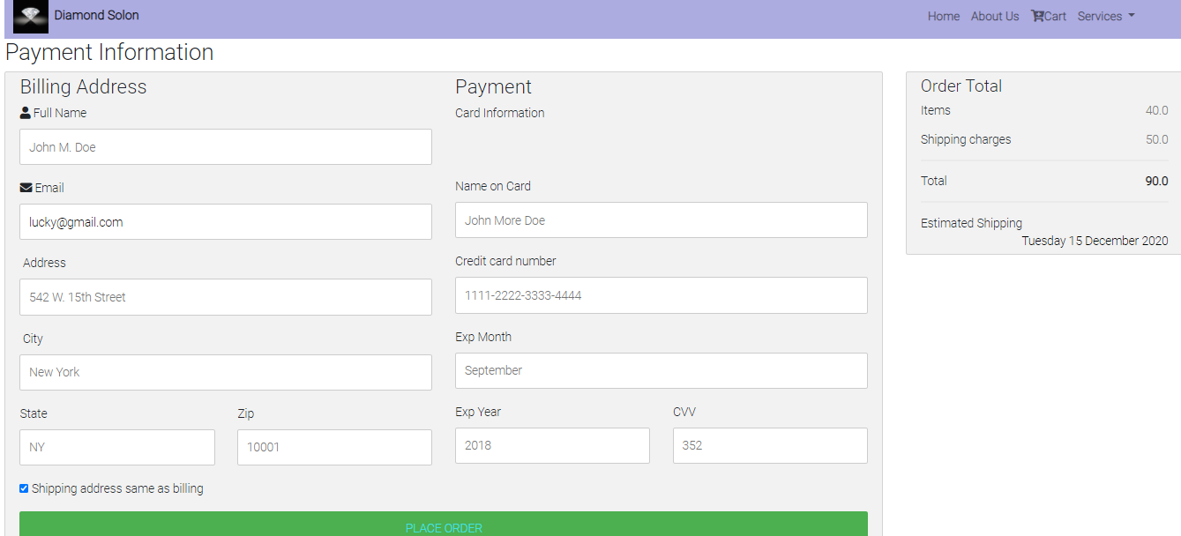 ON the cart page user can add or delete the quantity of the product, apply the discount code and check out.

On the check out page user need to fill all the details required for payment and place the order. Then user will get the below confirmation page.

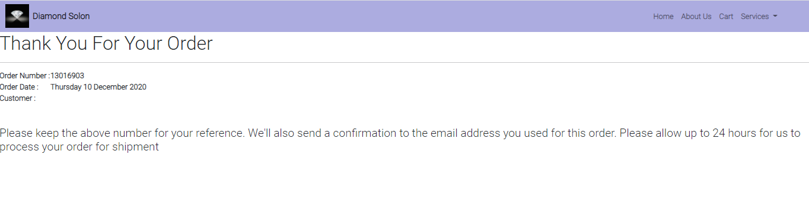

# Hair care

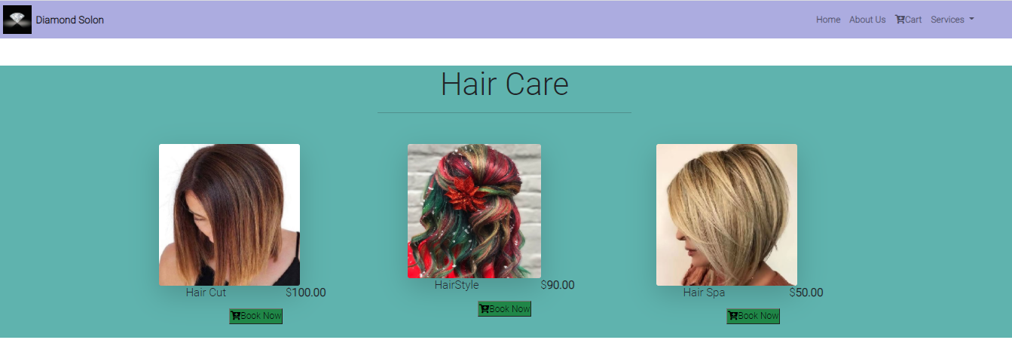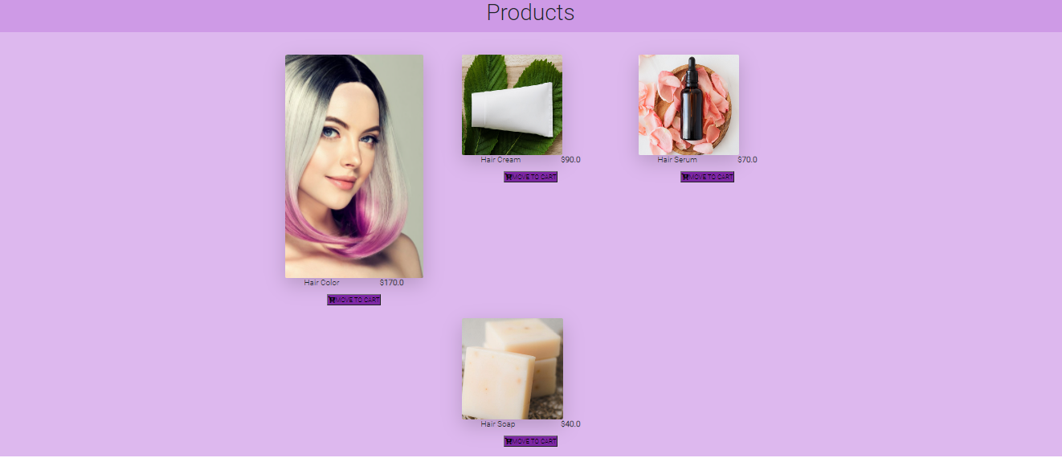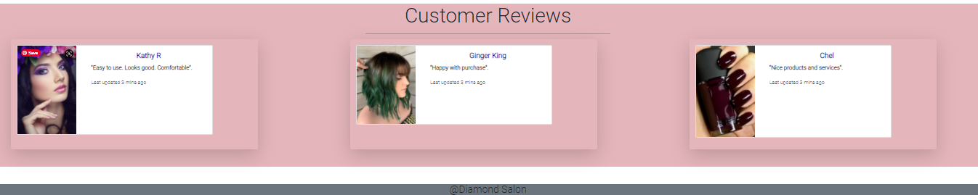

This page provides the products and services for hair care, navigation is same such explained in the makeup section.

# Nail Care

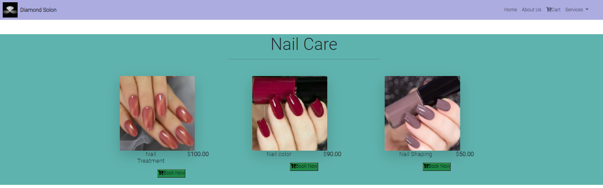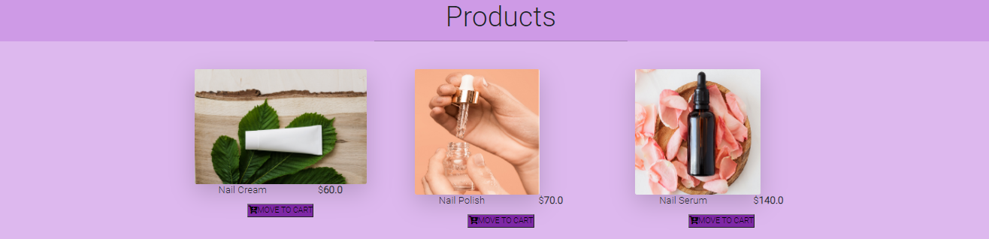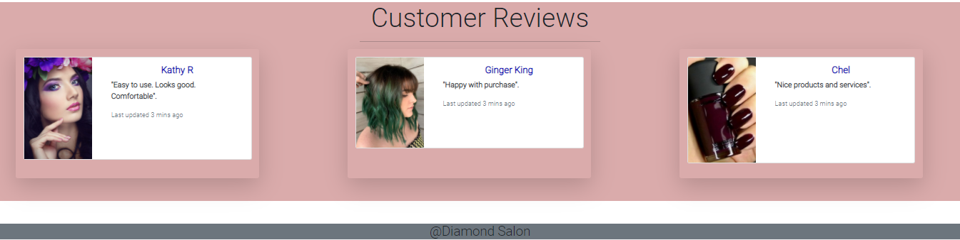

This page provides the products and services for nail care, navigation is same such explained in the makeup section.

# About Us page:

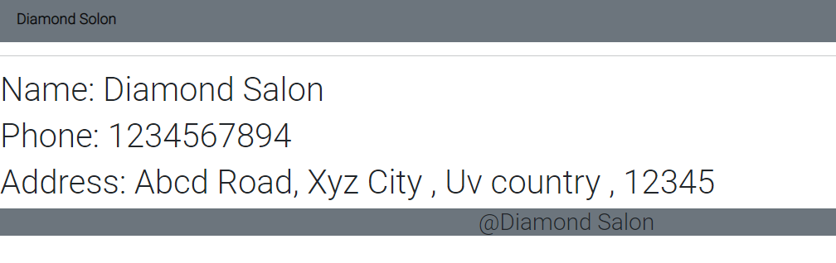

# Database

